**Bloater** *Coregonus hoyi*

Most caught at a single site: 4537 ~ Total collected all years: 121173

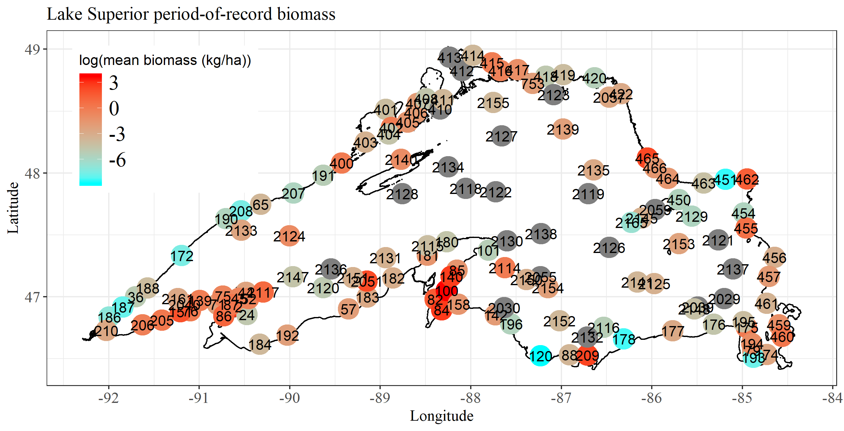

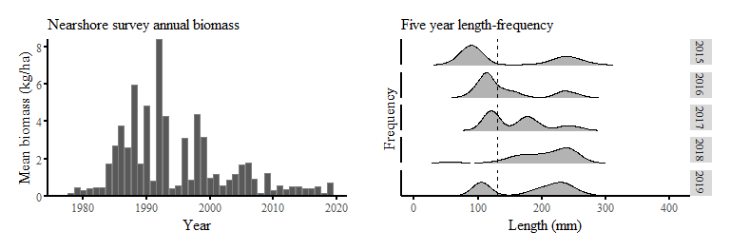

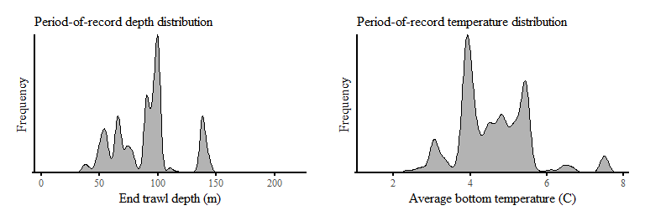

**Cisco (Lake Herring)** *Coregonus artedi*

Most caught at a single site: 25339 ~ Total collected all years: 298680

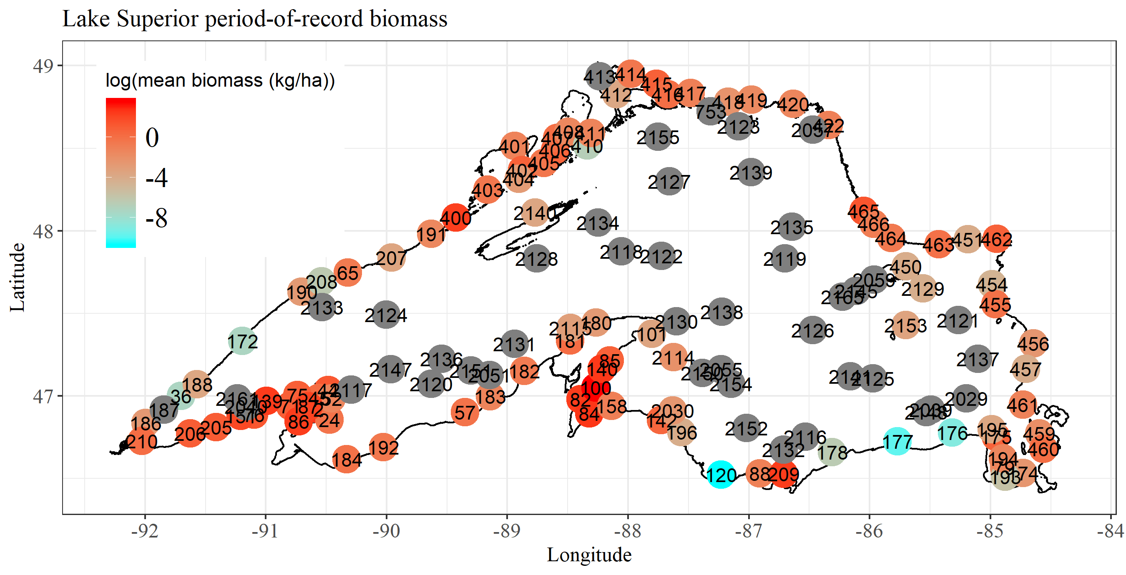

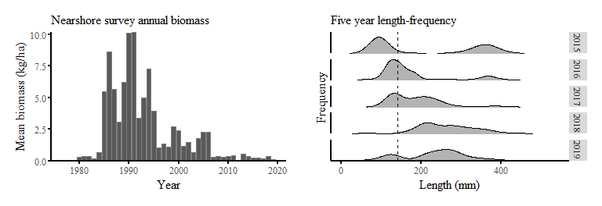

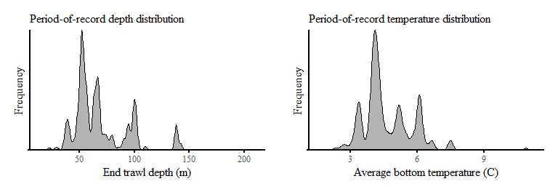

**Kiyi** *Coregonus kiyi*

Most caught at a single site: 324 ~ Total collected all years: 14171

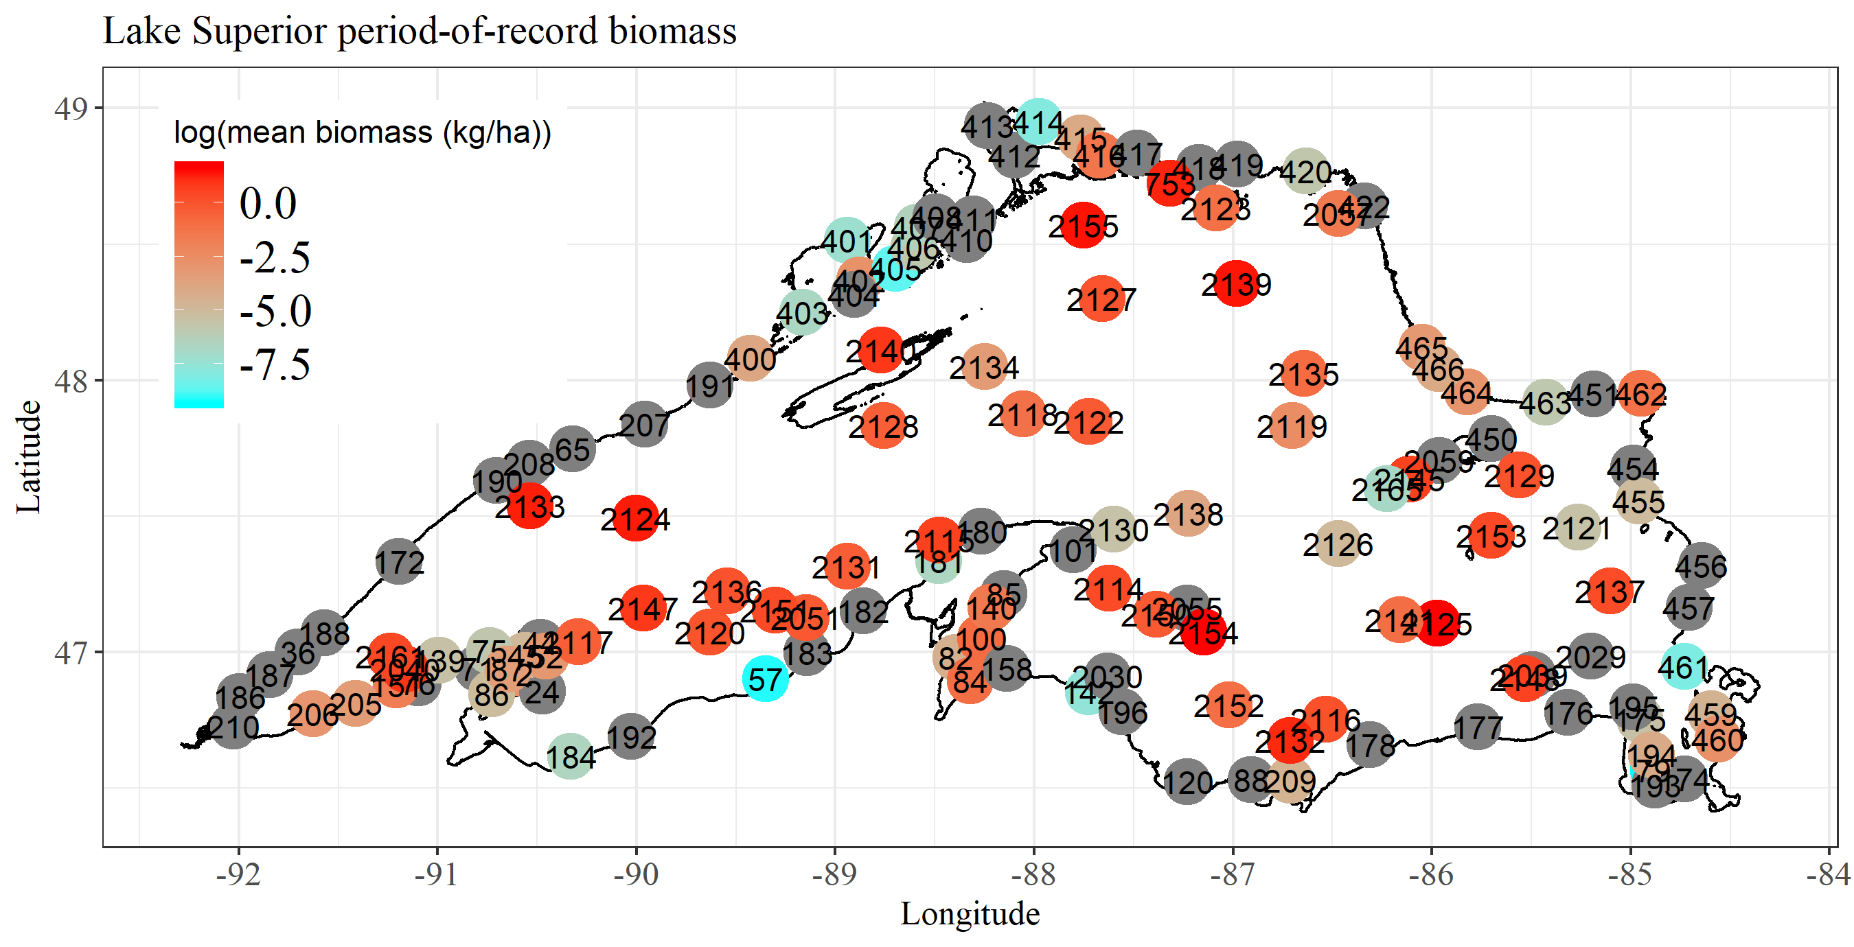

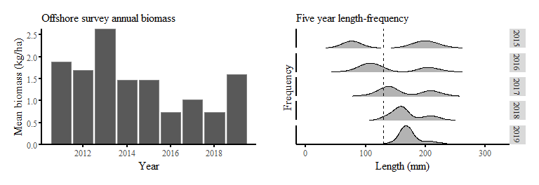

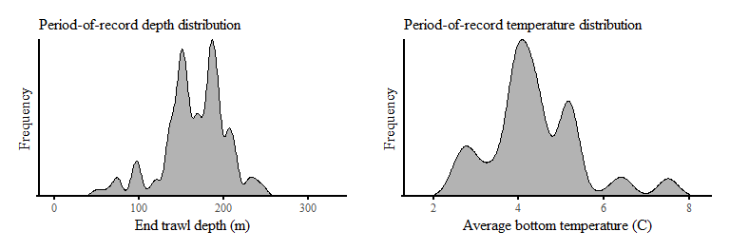

**Rainbow Smelt** *Osmerus mordax*

Most caught at a single site: 12506 ~ Total collected all years: 698932

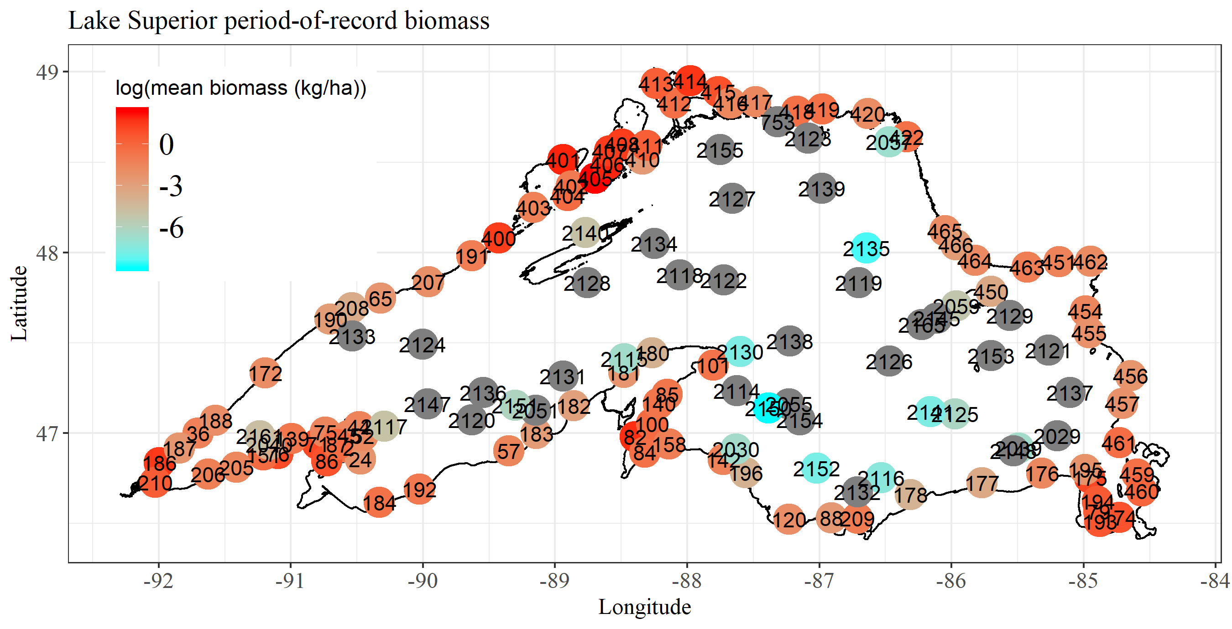

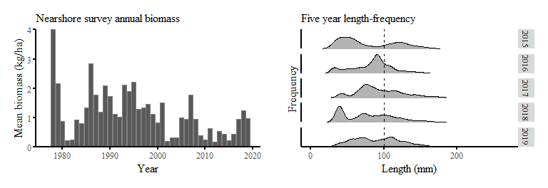

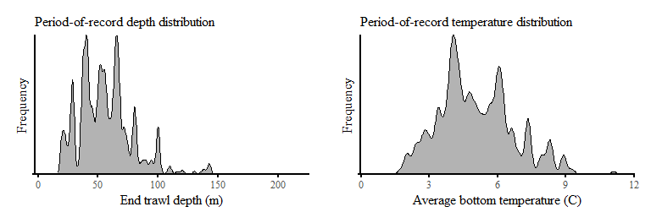

**Lake Whitefish** *Coregonus clupeaformis*

Most caught at a single site: 5670 ~ Total collected all years: 68035

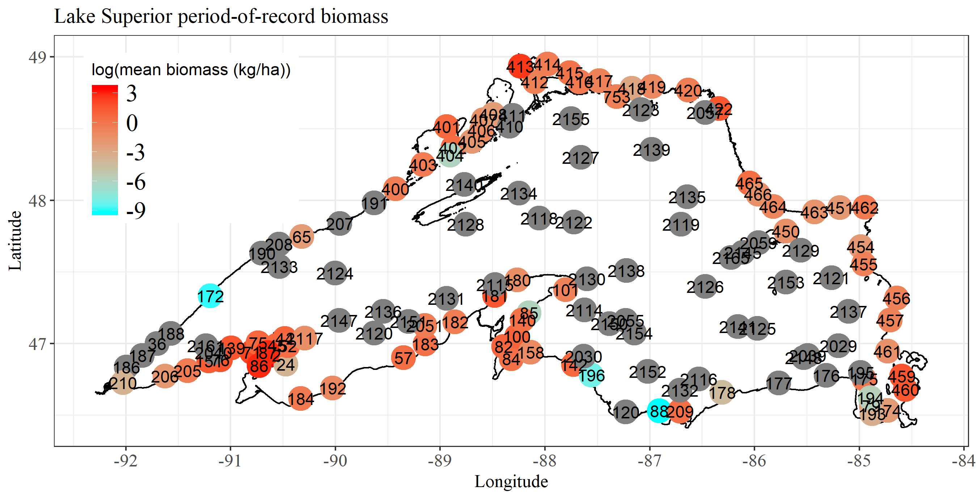

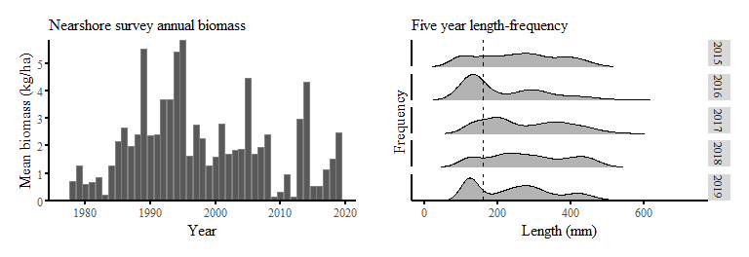

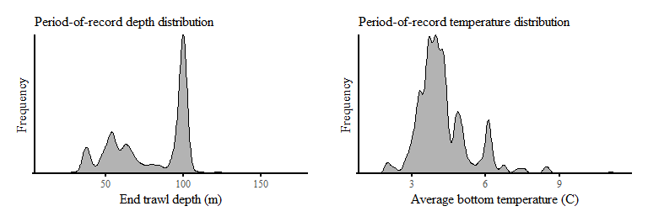

**lean Lake Trout** *Salvelinus namaycush*

Most caught at a single site: 160 ~ Total collected all years: 5088

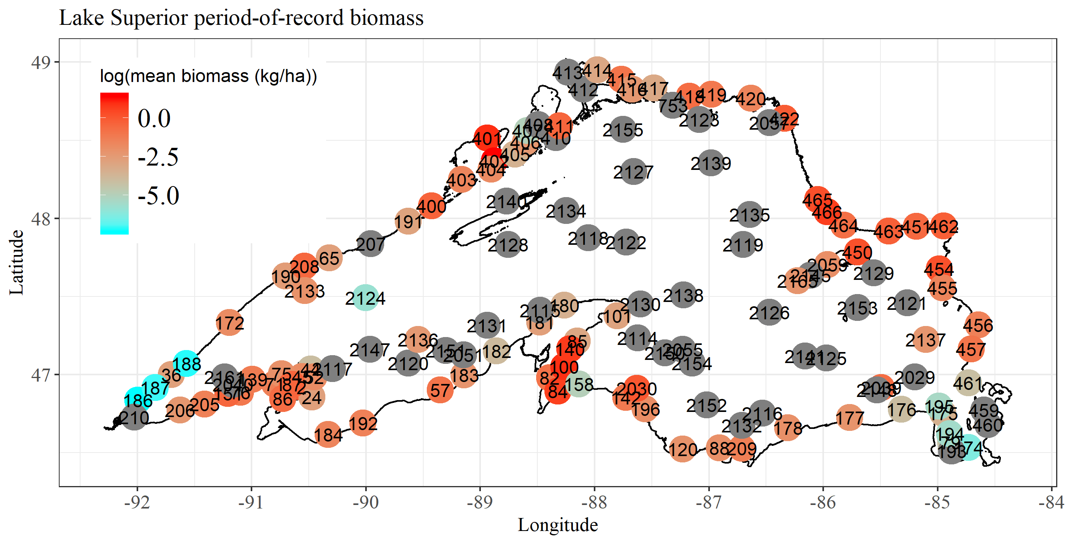

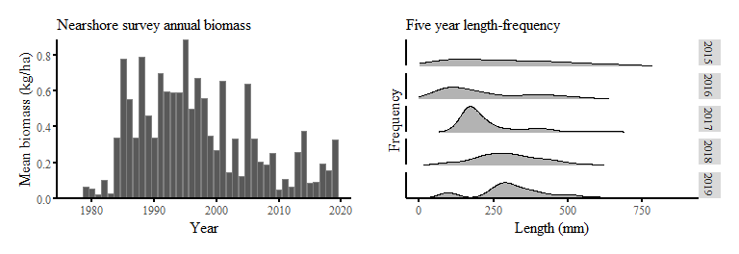

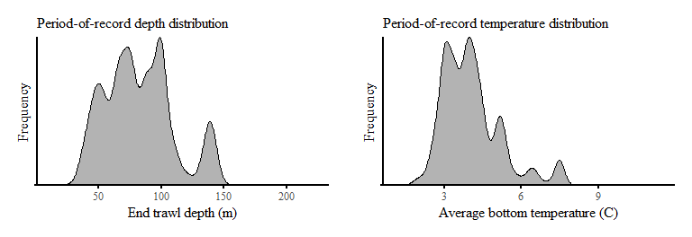

**siscowet Lake Trout** *Salvelinus namaycush siscowet*

Most caught at a single site: 75 ~ Total collected all years: 3249

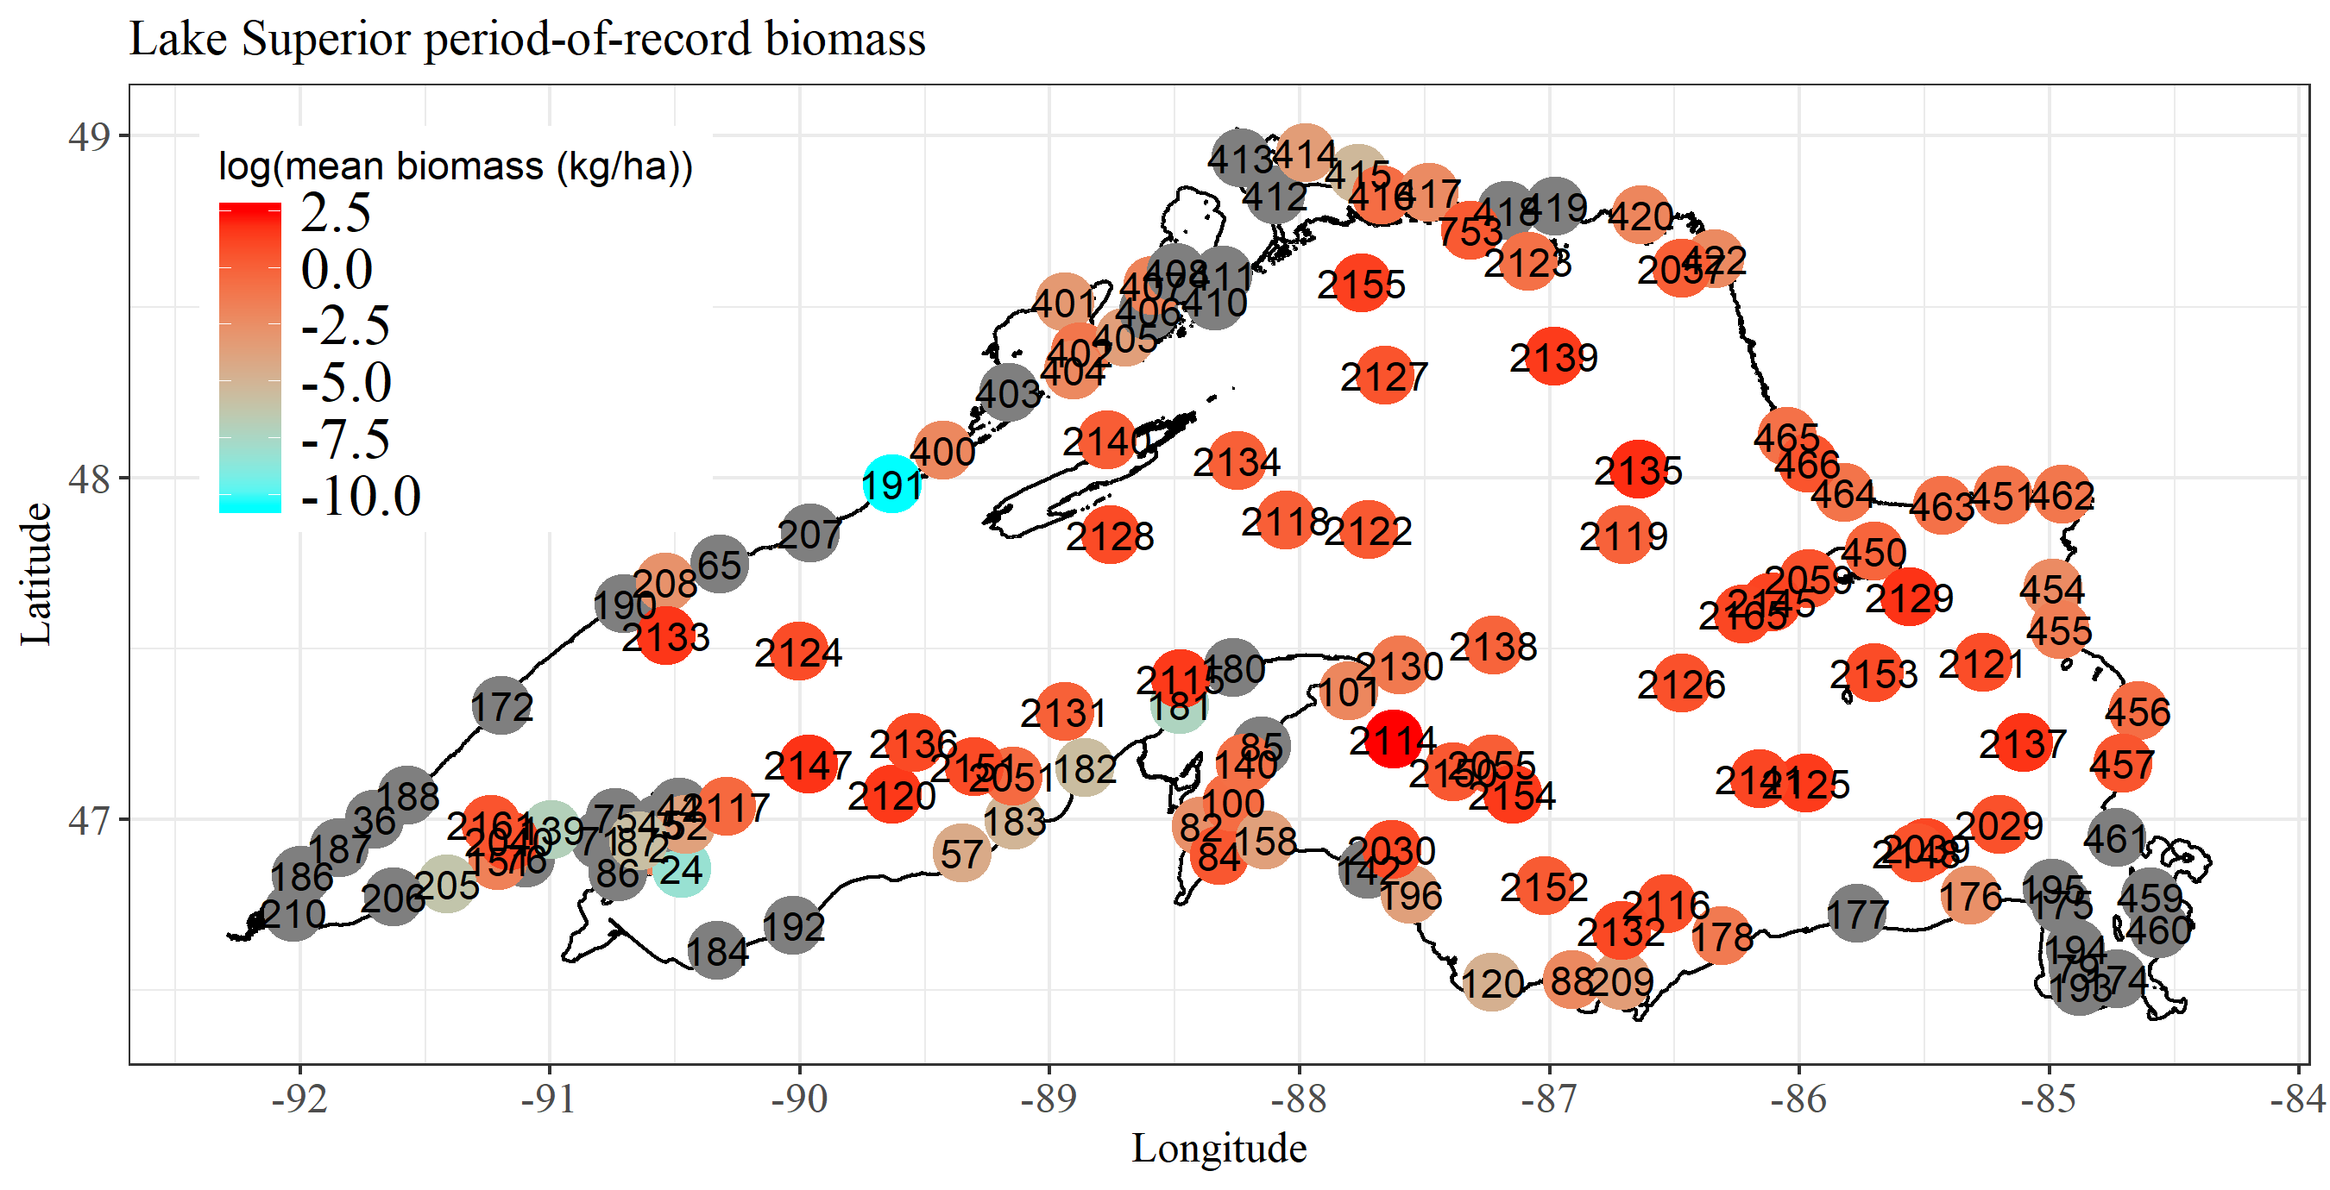

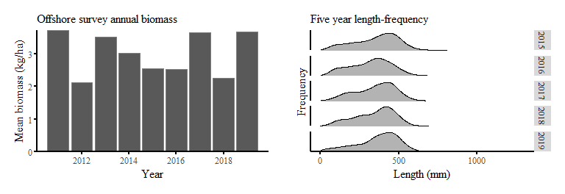

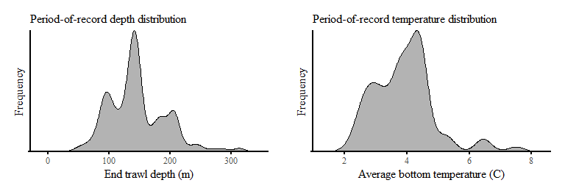

**Deepwater Sculpin** *Myoxocephalus thompsonii*

Most caught at a single site: 3235 ~ Total collected all years: 121716

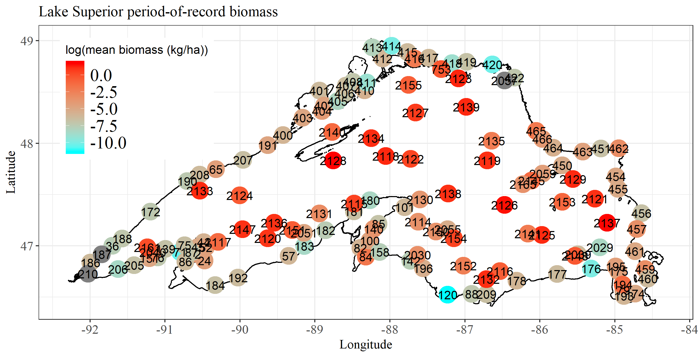

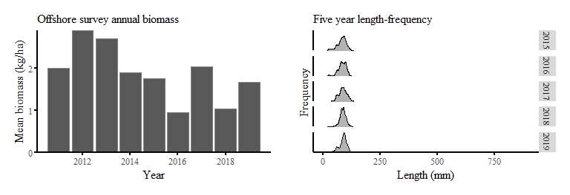

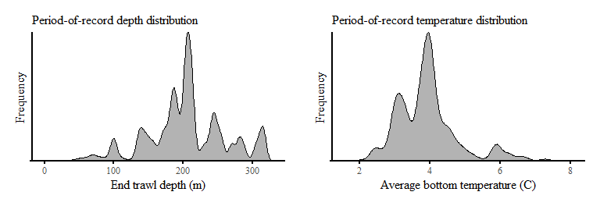

**Ninespine Stickleback** *Pungitius pungitius*

Most caught at a single site: 11499 ~ Total collected all years: 172932

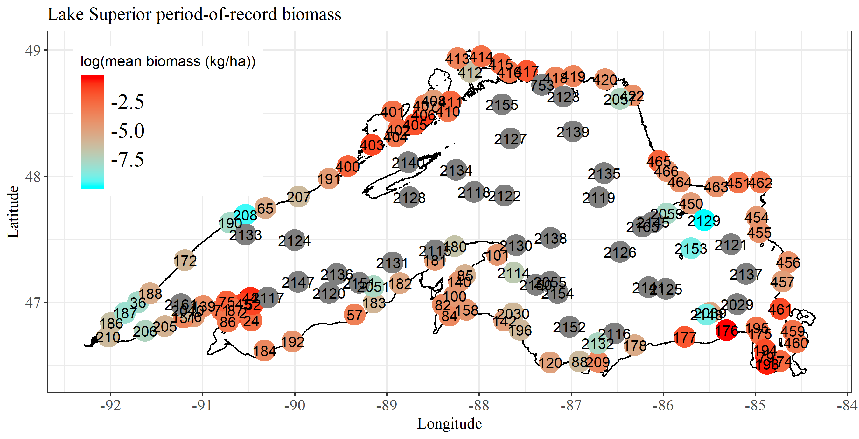

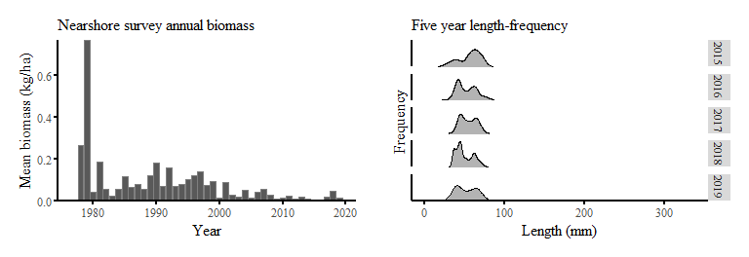

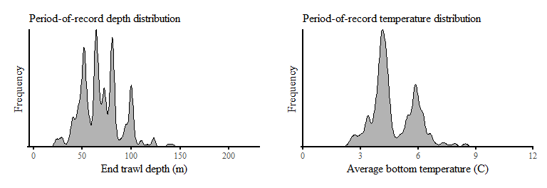

**Trout-perch** *Percopsis omiscomaycus*

Most caught at a single site: 2566 ~ Total collected all years: 59939

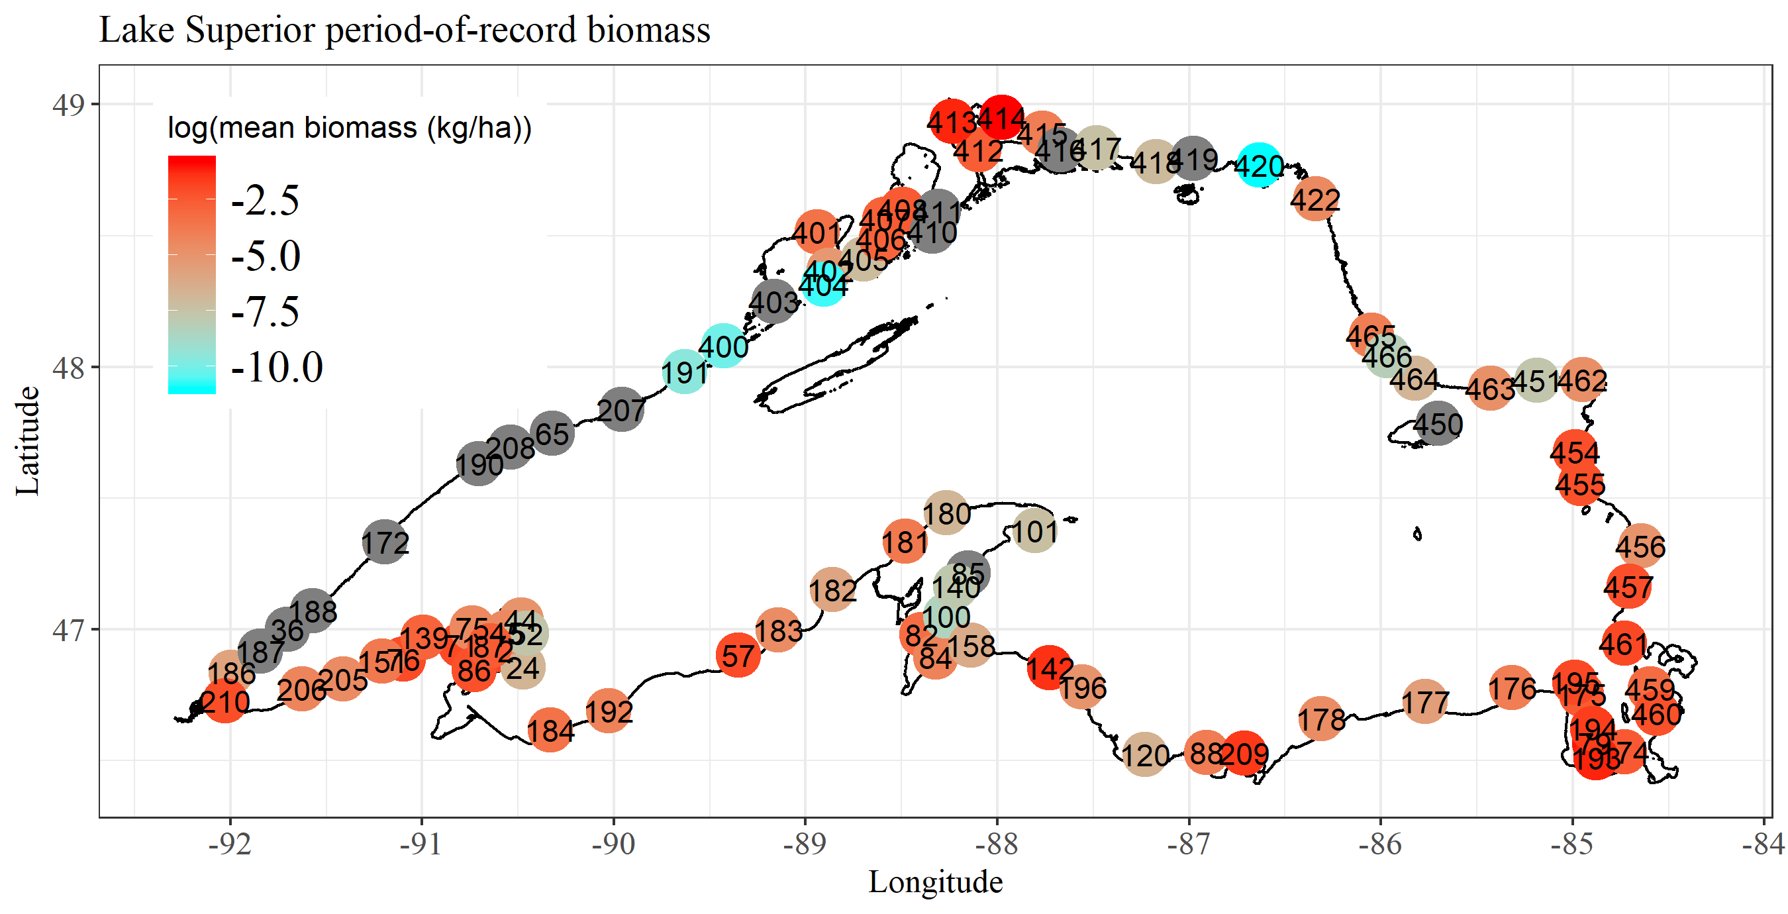

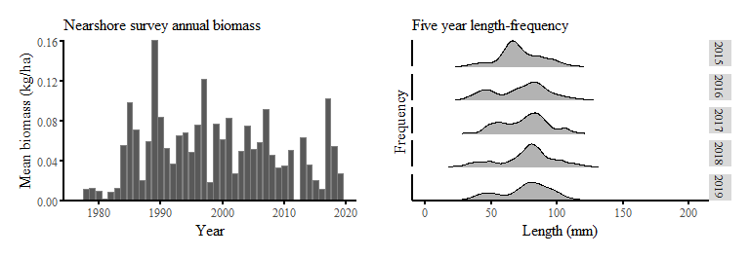

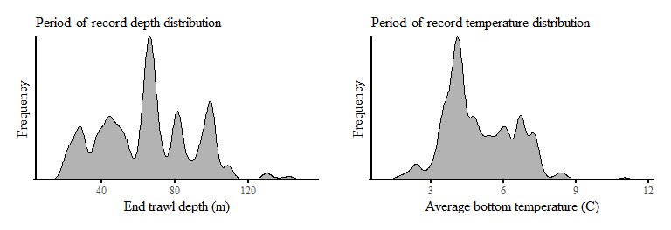

**Longnose Sucker** *Catostomus catostomus*

Most caught at a single site: 98 ~ Total collected all years: 2573

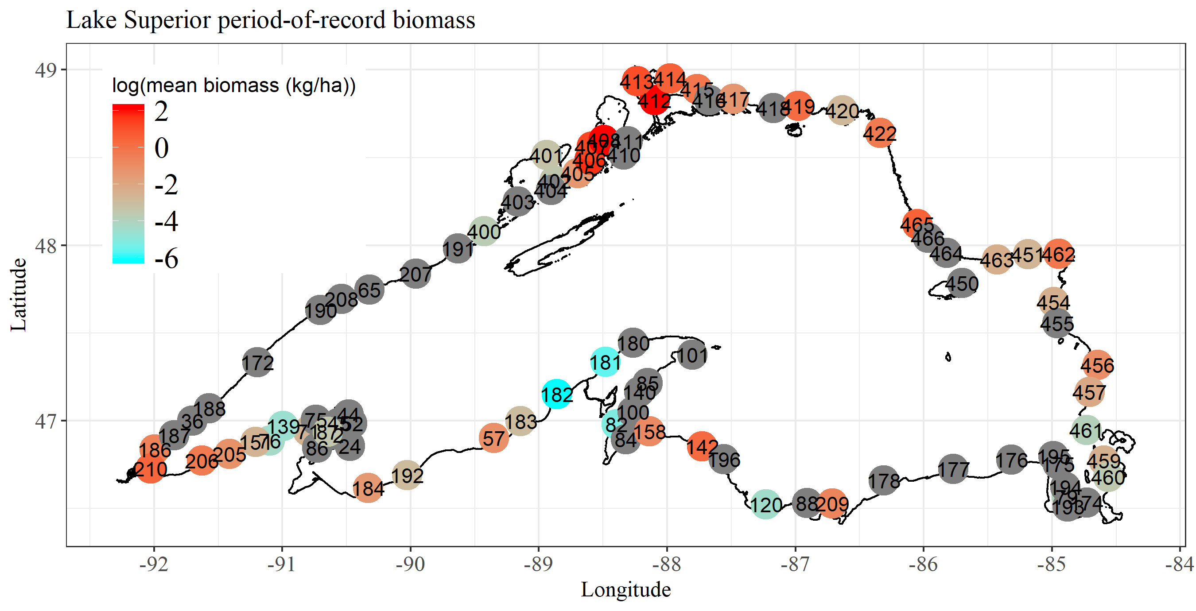

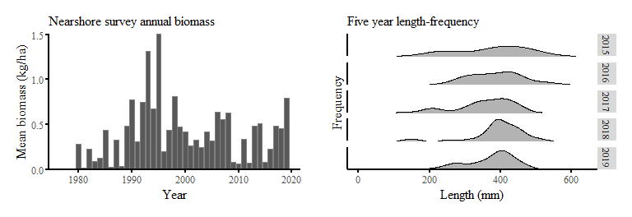

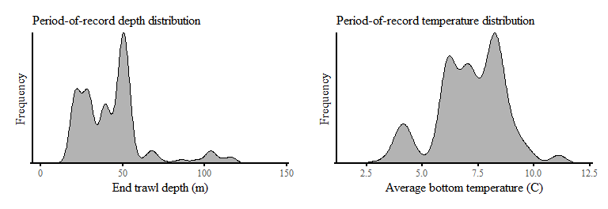

**Pygmy Whitefish** *Prosopium coulteri*

Most caught at a single site: 2633 ~ Total collected all years: 68443

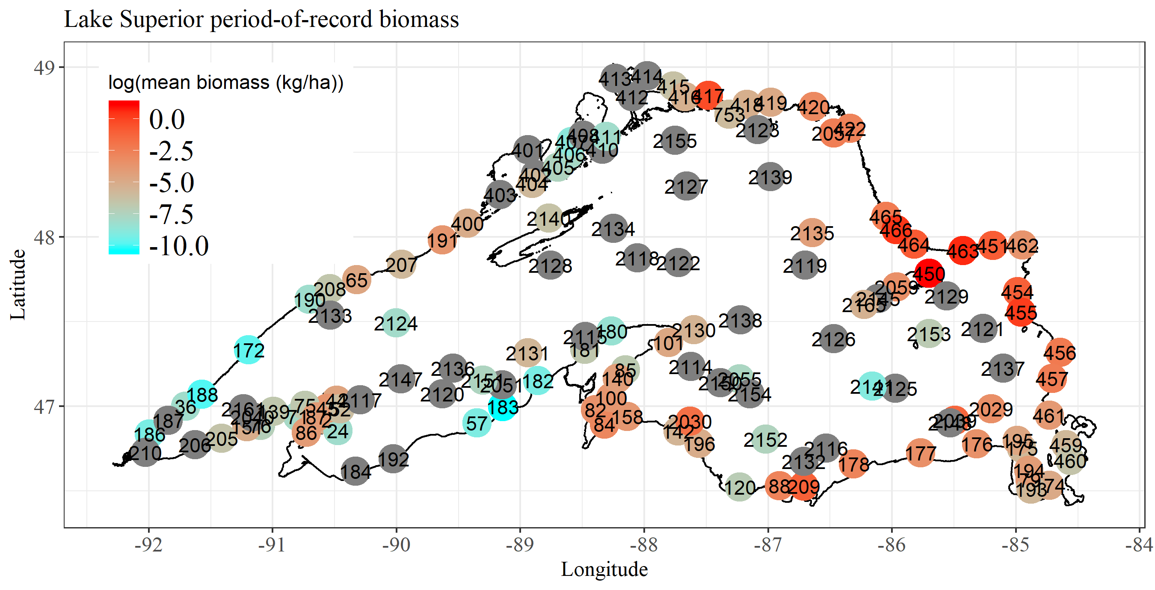

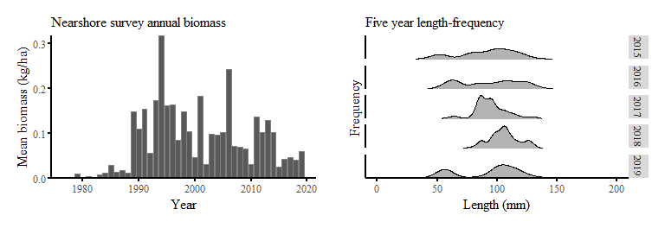

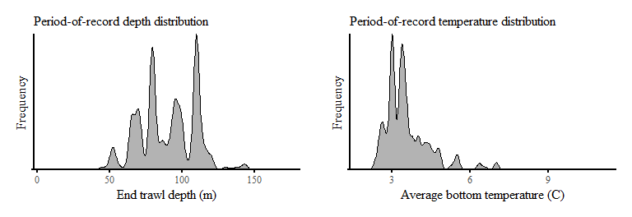

**Slimy Sculpin** *Cottus cognatus*

Most caught at a single site: 919 ~ Total collected all years: 54159

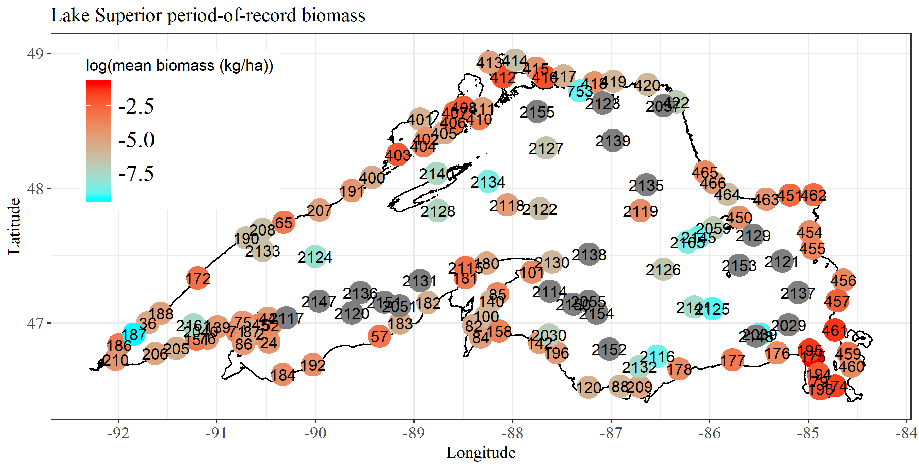

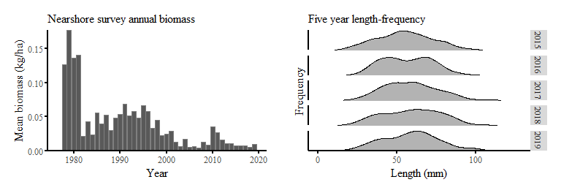

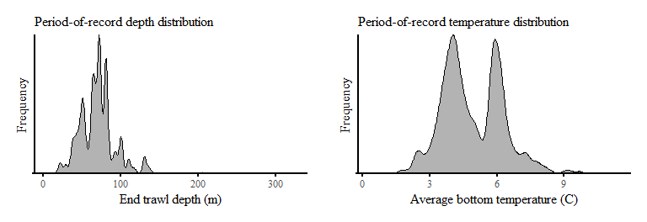

**Spoonhead Sculpin** *Cottus ricei*

Most caught at a single site: 407 ~ Total collected all years: 9764

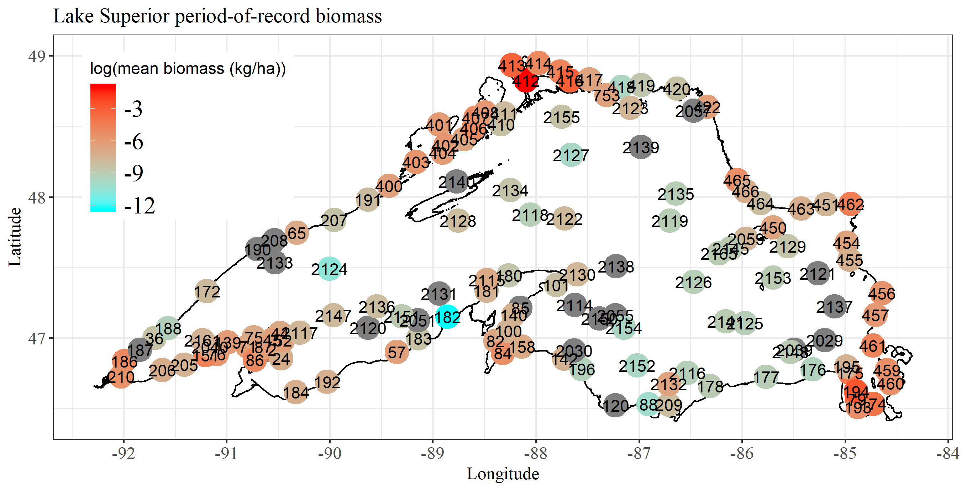

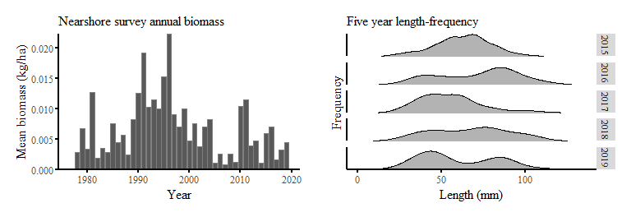

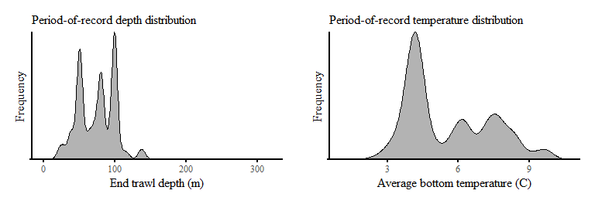

**Burbot** *Lota lota*

Most caught at a single site: 14 ~ Total collected all years: 796

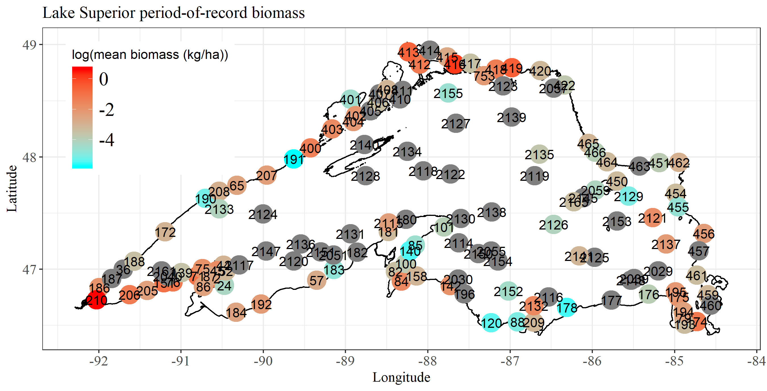

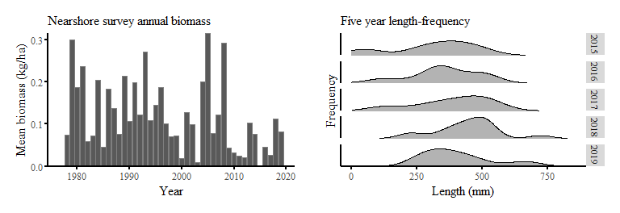

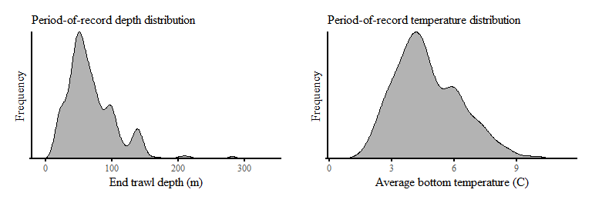

**hatchery Lake Trout** *Salvelinus namaycush*

Most caught at a single site: 53 ~ Total collected all years: 2614

